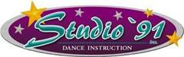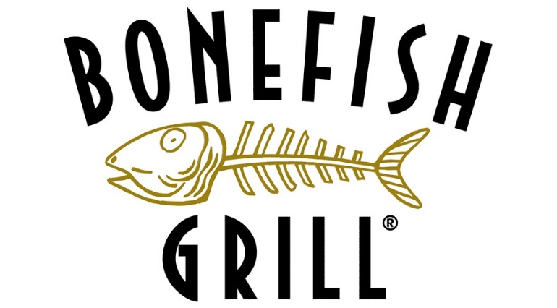

Bonefish Grill Camp Hill presents Studio ’91 charity night.

Monday December 2nd from 11 a.m. until 10 p.m.

Come enjoy the best food and service around while also raising money for Studio ’91.

15% of your bill will be donated towards Studio ’91 if you mention this flyer or turn it in to your server.

Bonefish Grill Camp Hill is located at 3505 Gettysburg Rd Camp Hill, PA 17011

If you would like to make reservations please call

(717)737-6541